`

|  |  |  |  |
| --- | --- | --- | --- |
| Document filename: | **Design Document (FGM Discovery)** | | |
| Project / Programme | **Interoperability Standards Service** | Project | **FGM Discovery** |
| Document Reference |  | | |
| Project Manager | Jo Wan | Status | **Draft** |
| Owner | Dave Crampin | Version | **0.1** |
| Author | David Lawson | Version issue date | **02/06/2023** |

**FGM API Discovery**

Reviewed by

This document has been reviewed by the following people:

|  |  |  |  |  |
| --- | --- | --- | --- | --- |
| Name | Signature | Title | Date | Version |
|  |  |  |  |  |
|  |  |  |  |  |

Document Control:

The controlled copy of this document is maintained in the NHS Digital corporate network. Any copies of this document held outside of that area, in whatever format (e.g. paper, email attachment), are considered to have passed out of control and should be checked for currency and validity.

Approved by

This document must be approved by the following people:

|  |  |  |  |  |
| --- | --- | --- | --- | --- |
| Name | Signature | Title | Date | Version |
|  |  |  |  |  |
|  |  |  |  |  |

Document Control:

The controlled copy of this document is maintained in the NHS Digital corporate network. Any copies of this document held outside of that area, in whatever format (e.g. paper, email attachment), are considered to have passed out of control and should be checked for currency and validity.

**Contents**

1. Introduction 4

1.1. Purpose of Document 4

1.2. Objectives 4

2. Stakeholder List 4

3. Requirements 5

3.1. Overview / Activity Diagram 5

3.2. Data or Information Model 5

3.3. Use Cases 5

3.4. Scope 7

3.5. Documented Requirements 7

3.6. Architectural Design 8

3.8. High-Level FHIR Design 8

3.9. Options Appraisal 10

3.10. Issues/Decision Log 30

4. Design Authority Approval 31

# Introduction

## 1.1. Purpose of Document

The purpose of the Design Document is to collate the background and rationale for the development of the NWR-1866.

## 1.2. Objectives

This is a request for discovery work to propose options for a FHIR FGM-API to add, edit & remove FGM indicators and upload for onward sharing into other health and care settings.

We are looking to build an API to FHIR UK Core R4 Standards, this API will just replicate the functionality that is available in the current FGM write API. The reason for the re-build is that the current API is built to DSTU2 and that is no longer supported.

The FGM System provides the ability to display an alert message when a patient with female genitalia under 18 years old has a family history of FGM, as recorded in the FGM-IS service. Note that previously this alert indicated a patient’s risk of FGM but following a change in the FGM-IS service ([DCB2112 information standard)](https://digital.nhs.uk/data-and-information/information-standards/information-standards-and-data-collections-including-extractions/publications-and-notifications/standards-and-collections/dcb2112-fgm-information-sharing-local-system-integration) this now indicates a patient’s family history of FGM.

The FGM-IS Service supports the wider Female Genital Mutilation Prevention (FGMP) Programme which is in place to protect, prevent and care for children and vulnerable adults who have a family history of FGM. This service will allow Healthcare professionals and other government organisations (with an appropriate relationship), to indicate children and vulnerable adults who are at risk of FGM. This information will be available in the following settings: GP systems, Child Health Systems and other government agencies.

The FGM Service should support the following functionality:

* View patient FGM Flag
* Create patient FGM flag
* Delete patient FGM flag

The current FHIR DSTU2 1.0.2 specification can be found here: [Introduction to the FGM Information Sharing Service | fgm-risk-indication-service (developer.nhs.uk)](https://developer.nhs.uk/apis/fgm-v2.1/index.html)

# Stakeholder List

List stakeholder’s name and role, e.g.

* Sponsor - Jill Sharples
* Project Manager - Clare Cooke
* Architect - David Fletcher
* Technical Lead - IOPS (david.lawson10@nhs.net, david.barnet@nhs.net)
* Business Analyst - Chris Knowles
* (First of Type) Implementors - GP Suppliers – Principal & New Mkt entrants Maternity suite software suppliers
* Suppliers - EMIS, TPP, Medicus

# Requirements

## 3.1. Overview / Activity Diagram

This activity diagram illustrates interactions between actors and systems using FGM-IS.

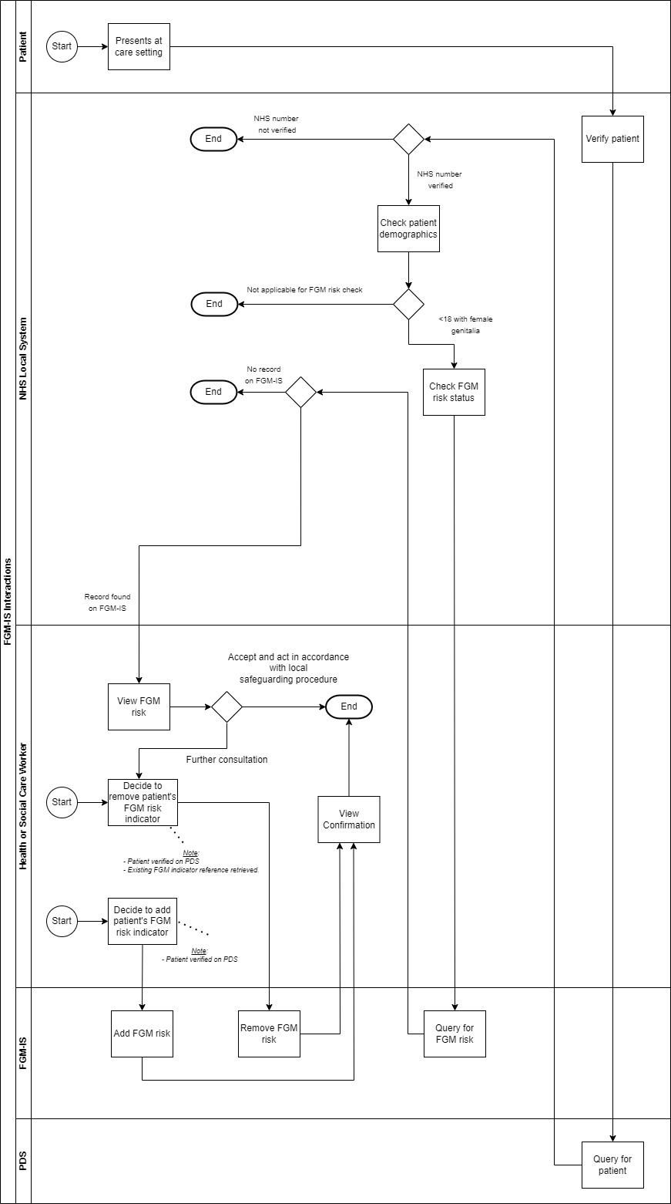

## 3.2. Data or Information Model

## 3.3. Use Cases

View FGM risk indicator

|  |  |
| --- | --- |
| **Name** | View FGM risk indicator |
| Version | 1.0 |
| ID |  |
| Owner | NHS England |
| User Story Summary (Clinical Overview) | As ahealthcare worker,  I can viewthe patient’s FGM Indicator if the patient has any Family history of FGM. |
| Actors (Role) | Healthcare worker |
| Frequency of Use | Real-time |
| Triggers | Patient attends health setting and meets criteria for system to trigger FGM status query I.e. under 18 with female genitalia. |
| Pre-Conditions | Patient has a verified NHS number |
| Post Conditions | Healthcare worker is made aware of any risk of FGM |
| Main Course | The patient presents at the care setting.  The healthcare worker is made aware of the patient being at risk of FGM. |
| Alternate Course | Patient’s NHS number is not on FGM-IS. Nothing is presented to the health or social care. |
| Exception | System exception e.g. network access, RBAC failure, API error. |

Add FGM risk indicator

|  |  |
| --- | --- |
| Name | Add FGM risk indicator |
| Version | 1.0 |
| ID |  |
| Owner | NHS England |
| User Story Summary (Clinical Overview) | As ahealthcare worker,  I can add the patient’s FGM risk indicator if the patient has any family history of FGM. |
| Actors (Role) | Healthcare worker |
| Frequency of Use | Real-time |
| Triggers | Healthcare worker decides that the patient is at risk of FGM. Decision made to add FGM risk indicator. |
| Pre-Conditions | Patient has a verified NHS number |
| Post Conditions | FGM risk indicator added to FGM-IS for the patient |
| Main Course | The healthcare worker decides the patient is at risk of FGM.  The healthcare worker adds the risk indicator to FGM-IS. |
| Alternate Course | Patient already as an FGM risk indicator on FGM-IS and addition is rejected.  Patient is over 18 and addition of FGM risk indicator is rejected by FGM-IS. |
| Exception | System exception e.g. network access, RBAC failure, API error. |

Delete FGM risk indicator

|  |  |
| --- | --- |
| Name | Delete FGM risk indicator |
| Version | 1.0 |
| ID |  |
| Owner | NHS England |
| User Story Summary (Clinical Overview) | As ahealthcare worker,  I can delete the patient’s FGM risk indicator if it is no longer required. |
| Actors (Role) | Healthcare worker |
| Frequency of Use | Real-time |
| Triggers | Healthcare worker decides that the patient is no longer at risk of FGM. Decision made to deleted FGM risk indicator. |
| Pre-Conditions | Patient has a verified NHS number |
| Post Conditions | FGM risk indicator removed from FGM-IS for the patient |
| Main Course | The healthcare worker decides the patient should not have an FGM risk indicator recorded.  The healthcare worker removes the risk indicator from FGM-IS. |
| Alternate Course |  |
| Exception | System exception e.g. network access, RBAC failure, API error. |

## 3.4. Scope

### 3.4.1 In scope

The following care communications are currently supported using the FHIR ‘DSTU2’ 1.0.2 and are in scope for uplift to a FHIR R4 API.

* query a patient's FGM risk indicator status
* create an FGM indicator for a patient
* delete an FGM indicator for a patient

## 3.5. Documented Requirements

### 3.5.1 New Requirements.

1. The primary requirement around this discovery piece is to research and provide options for a FHIR R4 API enabling:
   1. A ‘view only’ capability within local NHS systems and Spine Mini Service Providers (SMSP). This will allow fully integrated query and response access to national FGM information sharing system from local NHS systems and SMSP’s.
   2. An ‘update’ capability within local NHS systems. Enabling additional create and delete capability for local NHS systems integration to the FGM-IS
2. The FGM-IS can only be updated by authorised healthcare professionals using Smartcards with the correct RBAC activity codes
3. Utilise FHIR UK Core / NHS England FHIR profiled resources. Avoid domain specific FHIR profiles – profile proliferation.
4. Consider best practice in proposed options
   1. NHS Digital [API policies and best practice](https://digital.nhs.uk/developer/guides-and-documentation/api-policies-and-best-practice)
   2. NHS Digital patterns book

## 3.6. Architectural Design

Aligning with the NHS Digital [API policies and best practice](https://digital.nhs.uk/developer/guides-and-documentation/api-policies-and-best-practice) we propose to provide:

* a set of [FHIR RESTful APIs on the NHS England API platform.](https://digital.nhs.uk/developer/guides-and-documentation/our-api-technologies#fhir) This will provide a modern experience using current open standards such as [REST](https://digital.nhs.uk/developer/guides-and-documentation/our-api-technologies#basic-rest) and [FHIR.](https://digital.nhs.uk/developer/guides-and-documentation/our-api-technologies#fhir)
* The APIs will access the same data on the spine that is used for the existing FGM service.
* API headers required will align to the standard APIM (API Management) headers: [HTTP headers for your API](https://nhsd-confluence.digital.nhs.uk/pages/viewpage.action?spaceKey=APM&title=HTTP+headers+for+your+API#HTTPheadersforyourAPI-APIMplatformrequeststandardheaders) or if available in JWT then derived from there (need advice from APIM)

Access:

* This API is for healthcare worker use only.

**3.7. FHIR Paradigm**

[FHIR RESTful APIs.](https://digital.nhs.uk/developer/guides-and-documentation/our-api-technologies#fhir) This aligns with NHS England APIM best practice and strategy.

### 3.7.1 Transport

SPINE / HTTP – this matches the current access method for FGM.

## 3.8. High-Level FHIR Design

The mapping of each data item considered at a high level is as below. These will be discussed further in the option appraisal.

1. For Source Author (refer to ‘Headers’ section for further details).
   1. [PractitionerRole](https://simplifier.net/hl7fhirukcorer4/ukcorepractitionerrole) / [Practitioner](https://simplifier.net/hl7fhirukcorer4/ukcorepractitioner)
   2. o*r SDS (guidance from APIM required)*
2. For Source Organization (refer to ‘Headers’ section for further details)
   1. [Organization](https://simplifier.net/hl7fhirukcorer4/ukcoreorganization)
   2. *or* ODS (guidance from APIM required)
3. For Source application (refer to ‘Headers’ section for further details)
   1. Header bearer token (ASID)
4. For NHS number query parameter
   1. URL search parameter
5. Risk Indicator
   1. [Flag](https://simplifier.net/hl7fhirukcorer4/ukcoreflag)
   2. *or* [FamilyMemberHistory](https://simplifier.net/hl7fhirukcorer4/ukcore-familymemberhistory)

### 3.8.1 Headers

Any uplifted FGM FHIR API will require metadata to define the source author, system and organization. The below are standard APIM headers that could be used to pass that metadata. The exact header used for each will be driven by the current APIM preference at delivery stage.

|  |  |
| --- | --- |
| **Name** | **Description** |
| NHSD-End-User-Organisation-ODS | Required. Type: [token](https://hl7.org/implement/standards/FHIR/search.html%23token)  The identifier for the end user organization (ODS Code). The organisation which scopes the role of the author (the organisation which employs the person who is the author – NHSD-Requesting-Practitioner).  **Note**: there is an ‘NHSD-End-User-Organisation' and ‘NHSD-End-User-Organisation-ODS'. Confirm with APIM which is preferred. Confirm with APIM if this can instead be inferred from OAUTH bearer token? |
| NHSD-Requesting-Practitioner | Required: Type: RequestingPractitionerToken  Requesting Practitioner described in an object based on a FHIR 'PractitionerRole' resource (Standard Base64 encoded JSON).  **Note**: Confirm with APIM if this can instead be inferred from OAUTH bearer token? Or can we just pass in the (SDS) user ID and other details are then looked up from spine? |
| Authorization | An OAuth 2.0 bearer token |
| NHSD-Session-URID | The user role ID (URID) for the current session. Also known as a user role profile ID (URPID). Note: confirm with APIM if this is an option of application restricted APIs. |
| X-Correlation-ID | A globally unique identifier (GUID) for the request, which we use to trace the request if you contact our helpdesk. Mirrored back in a response header. Avoid. characters. |
| X-Request-ID | A globally unique identifier (GUID) for the request, which we use to de-duplicate repeated requests. Must be a universally unique identifier (UUID) (ideally version 4). If you re-send a failed request, use the same value in this header. Mirrored back in a response header. |

## 3.9. Options Appraisal

### 3.9.1 Option 1 – Model on Flag.

This option considers use of Flag resource to model an FGM risk indicator.

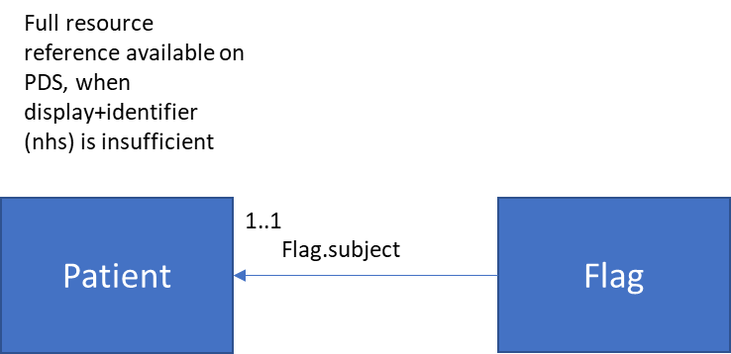

Mapping:

A high level mapping to the current FGM Flag:

|  |  |
| --- | --- |
| *Data item* | *FHIR Target* |
| FGM Risk Indicator | Flag.code |
| Start date | Flag.period.start |
| NHS identifier | Flag.subject.identifier |

Example (FGM):

{

"resourceType": "Flag",

"id": "a6a6a92a-8247-4250-b1c7-10cda16f0310",

"status": "active",

"code": {

"coding": [

{

"system": "http://snomed.info/sct",

"code": "902961000000107",

"display": "Family history of FGM (female genital mutilation)"

}

],

"text": "Family history of FGM (female genital mutilation)"

},

"subject": {

"identifier": {

"system": "https://fhir.nhs.uk/Id/nhs-number",

"value": "9000000009"

}

},

"period": {

"start": "2019-12-10T13:00:00+00:00"

}

}

Search interaction:

* **GET** Flag?patient:identifier=https://fhir.nhs.uk/Id/nhs-number|9000000009

Headers

|  |  |
| --- | --- |
| *Data item* | *Header* |
| Source author | NHSD-Requesting-Practitioner |
| Source application | Authorization (should contain ASID) |
| Source organization (*optional*) | NHSD-End-User-Organisation-ODS |

Parameters

|  |  |
| --- | --- |
| *Name* | *Description* |
| patient:identifier | Required. Type: [token](https://hl7.org/implement/standards/FHIR/search.html%23token)  The patient's NHS number. The primary identifier of a patient across systems, unique to NHS England and Wales.  Example: [https://fhir.nhs.uk/Id/nhs-number|4857773456](https://fhir.nhs.uk/Id/nhs-number%7C4857773456) |

Create interaction:

* **Post** /Flag

Headers

|  |  |
| --- | --- |
| *Data item* | *Header* |
| Source author | NHSD-Requesting-Practitioner |
| Source application | Authorization (should contain ASID) |
| Source organization (*optional*) | NHSD-End-User-Organisation-ODS |

Parameters

|  |  |
| --- | --- |
| *Name* | *Description* |
| N/A for interaction | |

Request

|  |  |
| --- | --- |
| *Body* | Description |
| Flag | Reference FGM Flag example above.  Note: it assumed the patient’s GP organisation will be drawn from PDS rather than being included in the payload. The patient GP organisation is included in the existing API as [spine-gp-organization-1-0](https://fhir.nhs.uk/StructureDefinition/spine-gp-organization-1-0) profile. |

Errors

|  |  |
| --- | --- |
| *Name* | *Description* |
| Mandatory elements check | For FGM: Always need a *verified* patient, coding and period start. |
| Flag already exists | Patient already has a Flag with coding for ‘Family history of FGM (female genital mutilation)’. Can’t have more than 1. |
| Flag.code.coding | For an FGM Flag category the code must be:  "coding": [  {  "system": "http://snomed.info/sct",  "code": "902961000000107",  "display": "Family history of FGM (female genital mutilation)"  } |
| Patient is over 18 | PDS date of birth has patient as being over 18. |

Update interaction (only delete supported):

* **Put** /Flag/ac272f03-b4bc-41e2-97d3-cfe1c900110d

Headers

|  |  |
| --- | --- |
| *Data item* | *Header* |
| Source author | NHSD-Requesting-Practitioner |
| Source application | Authorization (should contain ASID) |
| Source organization (*optional*) | NHSD-End-User-Organisation-ODS |

Parameters

|  |  |
| --- | --- |
| *Name* | *Description* |
| [id] | Required.  The UUID of the Flag to update |

Request

|  |  |
| --- | --- |
| *Body* | *Description* |
| Flag | Standard FHIR Flag. Including a removal reason extension. Flag.status set to something other than active. |

Example request:

{

"resourceType": "Flag",

"id": "a6a6a92a-8247-4250-b1c7-10cda16f0310",

"extension": [

{

"valueCodeableConcept": {

"coding": [

{

"code": "1",

"system": "https://fhir.hl7.org.uk/CodeSystem/FGMIS-RemovalReason-1",

"display": "The patient is no longer considered to be potentially at risk of FGM"

}

]

},

"url": "https://fhir.hl7.org.uk/StructureDefinition/Extension-FGMIS-RemovalReason-1"

}

],

"status": "inactive",

"code": {

"coding": [

{

"system": "http://snomed.info/sct",

"code": "902961000000107",

"display": "Family history of FGM (female genital mutilation)"

}

],

"text": "Family history of FGM (female genital mutilation)"

},

"subject": {

"identifier": {

"system": "https://fhir.nhs.uk/Id/nhs-number",

"value": "9000000009"

}

}

}

Errors:

|  |  |
| --- | --- |
| *Name* | *Description* |
| Delete reason | A delete reason is required for a PUT. Reasons selected from: <https://fhir.nhs.uk/ValueSet/fgm-delete-reason-codes-1-0> |
| Flag.status | Flag.status must not be active. Only inactive / entered-in-error are supported. |
| Details other than status changed | The Put operation only supports removal. Any other update is rejected e.g. updating the period.start, code, subject |

**3.9.1.1 Option 1 – Review:**

Pros

1. As this is standard REST then this allows consumer to control their own workflow rather than force extra information on them.
2. Aligns with APIM best practices and strategy.
3. Using Flag resources aligns with the DSTU2 FGM FHIR APIs. It's the most compelling/obvious modelling choice.

Cons

1. Using a PUT and an extension for the ‘removal reason’ may not be standard.

**3.9.1.2 Estimate timeline, cost and effort**

This option was **preferred** by the IOPS design authority, for the following reasons:

1. It aligns with current NHSE best practices.
2. Flag is a sound mapping for the FGM risk indicator information.
3. This option will satisfy the requirements of the FGM programme.

Estimate: 50 days. This option would be the preferred option to take forward at this time.

### 3.9.2 Option 2 – Incorporate into generic ‘Flag API’

This option proposes use of Flag resource. FGM Flags could be incorporated in a strategic Flag API that incorporates other NHS flags (e.g. Reasonable Adjustments, CP-IS etc...).

The Flag API would have to conform to a common pattern suitable to the other services. A top level Flag with deeper information in the common *flag-detail* extension. The resource linked to in flag-detail would be a resource most relevant to that Flag type. Patient and Organization references would be references to national record stores – PDS or SDS. E.g.

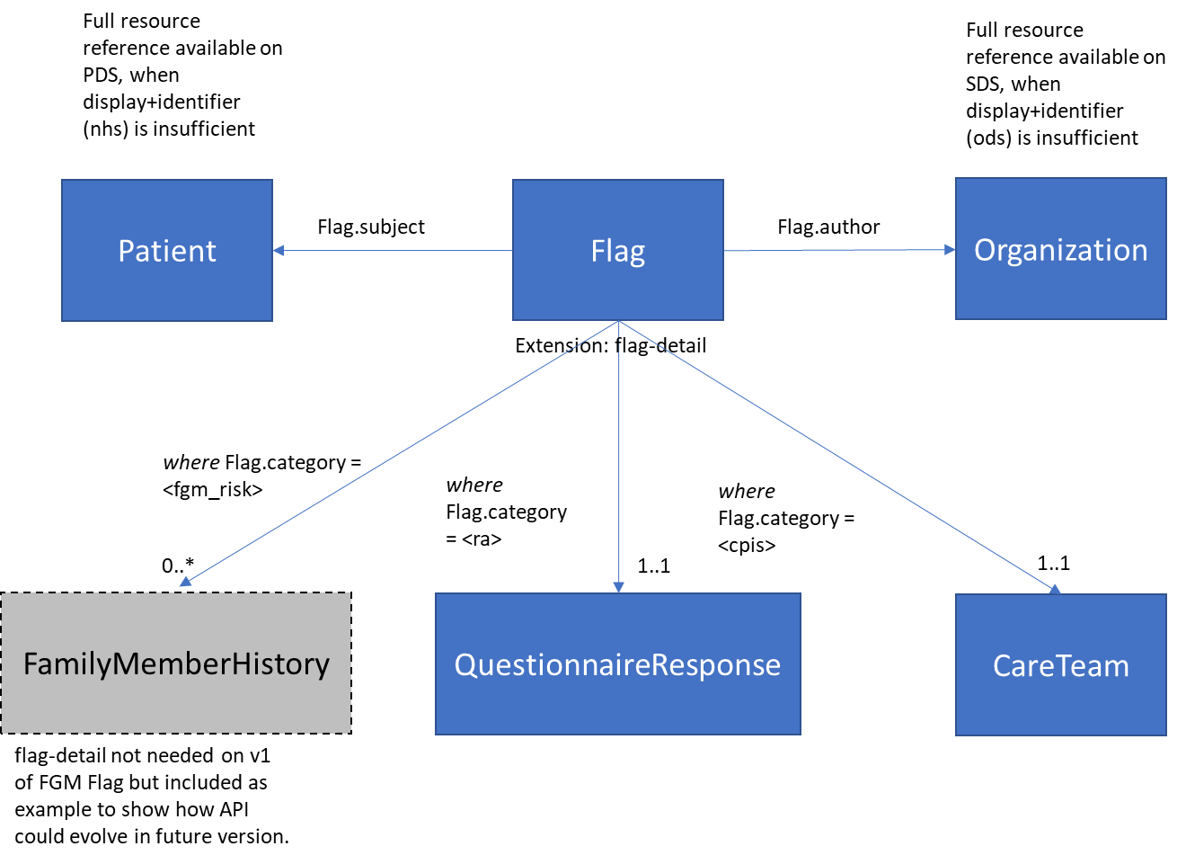

Mapping:

A high level mapping to the current FGM Flag:

|  |  |
| --- | --- |
| Data item | FHIR Target |
| FGM Risk Indicator | Flag.category, Flag.code |
| Start date | Flag.period.start |
| NHS identifier | Flag.subject.identifier |

Example (FGM):

{

"resourceType": "Flag",

"id": "UKCore-Flag-FGMFamilyHistory-Example",

"status": "active",

"category": [

{

"coding": [

{

"system": "http://terminology.hl7.org/CodeSystem/flag-category",

"code": "safety",

"display": "Safety"

}

],

"text": "Safety"

},

{

"coding": [

{

"system": "https://fhir.hl7.org.uk/CodeSystem/NHSEngland-FlagService-Category",

"code": "fgm_risk",

"display": "FGM Risk Indicator"

}

],

"text": "FGM Risk Indicator"

}

],

"code": {

"coding": [

{

"system": "http://snomed.info/sct",

"code": "902961000000107",

"display": "Family history of FGM (female genital mutilation)"

}

],

"text": "Family history of FGM (female genital mutilation)"

},

"subject": {

"reference": "https://api.service.nhs.uk/personal-demographics/FHIR/R4/Patient/9000000009",

"display" : "Miss Davina Patient",

"identifier": {

"system": "https://fhir.nhs.uk/Id/nhs-number",

"value": "9000000009"

}

},

"period": {

"start": "2019-12-10T13:00:00+00:00"

}

}

Search interaction:

* **GET** Flag?patient:identifier=https://fhir.nhs.uk/Id/nhs-number|9000000009

Headers

|  |  |
| --- | --- |
| *Data item* | *Header* |
| Source author | NHSD-Requesting-Practitioner |
| Source application | Authorization (should contain ASID) |
| Source organization (*optional*) | NHSD-End-User-Organisation-ODS |

Parameters

|  |  |
| --- | --- |
| *Name* | *Description* |
| patient:identifier | Required. Type: [token](https://hl7.org/implement/standards/FHIR/search.html%23token)  The patient's NHS number. The primary identifier of a patient across systems, unique to NHS England and Wales.  Example: [https://fhir.nhs.uk/Id/nhs-number|4857773456](https://fhir.nhs.uk/Id/nhs-number%7C4857773456) |
| _include | Optional. Type: array[String]  Flag:patient – the patient whom is subject to the flag. Not needed for FGM but as a generic Flag pattern likely relevant. Can the API return back from PDS?  Flag:author– the Organization which created the Flag. Not needed for FGM but as a generic Flag pattern likely relevant. Can the API return back from SDS?  Example: GET Flag?patient:identifier=https://fhir.nhs.uk/Id/nhs-number|4857773456 &_include:Flag:patient  GET Flag?patient:identifier=https://fhir.nhs.uk/Id/nhs-number|4857773456 &_include:Flag:patient&_include:Flag:author |

Create interaction:

* **Post** /Flag

Headers

|  |  |
| --- | --- |
| *Data item* | *Header* |
| Source author | NHSD-Requesting-Practitioner |
| Source application | Authorization (should contain ASID) |
| Source organization (*optional*) | NHSD-End-User-Organisation-ODS |

Parameters

|  |  |
| --- | --- |
| *Name* | *Description* |
| N/A for interaction | |

Request

|  |  |
| --- | --- |
| *Body* | *Description* |
| Flag | Reference FGM Flag example above.  Note: it assumed the patient’s GP organisation will be drawn from PDS rather than being included in the payload. |

Errors:

|  |  |
| --- | --- |
| *Name* | *Description* |
| Flag.category | Likely different Flag category CRUD operations enabled at different stages. E.g FGM allowed, CPIS not yet.  Reject if application / role not allowed to create type of Flag. |
| Mandatory elements check | For FGM: Always need a *verified* patient, category and code, period start.  For others: Above elements + include flag-detail |
| Flag already exists | Patient already has a Flag with coding for ‘Family history of FGM (female genital mutilation)’. Can’t have more than 1. |
| Flag.category + code | For an FGM Flag category the code must be:  "coding": [  {  "system": "http://snomed.info/sct",  "code": "902961000000107",  "display": "Family history of FGM (female genital mutilation)"  } |
| Patient at risk of FGM is over 18 | For an FGM Flag category the PDS dob can’t be for a patient over 18. |

Read interaction: (for a Resource within flag-detail extension)

(**not in current FGM scope but included for overall option context** – FGM Flag has insufficient information to warrant anything in flag-detail currently)

* **GET** <Resource>/c7a07f476e5e40f990287f3705c16482

Headers

|  |  |
| --- | --- |
| *Data item* | *Header* |
| Standard APIM platform headers + anything bespoke for Flag type. | |

Parameters

|  |  |
| --- | --- |
| *Name* | *Description* |
| [id] | Required.  The UUID of the Resource |

Errors:

|  |  |
| --- | --- |
| *Name* | *Description* |
| Checks on Flag.category | Reject if application / role not allowed to read type of Flag. |

Update Interaction:

FGM Flag has insufficient information to warrant an update I.e. it’s just code, patient reference and start date. PUT is deemed more relevant than DELETE for FGM Flag soft delete as it requires a removal reason in the payload)

* **PUT /**Flag

Headers

|  |  |
| --- | --- |
| *Data item* | *Header* |
| Standard APIM platform headers + anything bespoke for Flag type. | |

Parameters

|  |  |
| --- | --- |
| *Name* | *Description* |
| [id] | Required.  The UUID of the Flag to update |

Request

|  |  |
| --- | --- |
| *Body* | *Description* |
| Flag | Standard FHIR Flag. Potentially including flag-detail extension and removal reason extension. |

Errors

|  |  |
| --- | --- |
| *Name* | *Description* |
| Flag.category | Likely different Flag category CRUD operations enabled at different stages.  Reject if application / role not allowed to create type of Flag. |
| Patient | Not allowed to change linked patient. |
| Mandatory elements check | Mandatory elements for specific flag category I.e. *verified* patient, category and code, period start, flag-detail |

#### 3.9.2.1 Option 2 Review

Pros

1. If progressed then NHS would have a generic Flag API which FGM would be one part of. RA, CP-IS could onboard into the generic API.
2. As this is standard REST then this allows consumer to control their own workflow rather than force extra information on them.

Cons

1. Incorporating into a strategic API would mean more stakeholders, requirements and funding questions (compared to one specific programme).
2. No search parameter on ‘category’ or ‘code’ in FHIR R4. Thus there is no standard way to ask for a filtered list of Flags e.g. just FGM, just RA. Not sure if this matters. May be able to filter the Flags returned by RBAC smartcard permission or alternative solution e.g. create a search parameter.

**3.9.2.2 Estimate timeline, cost and effort**

This option was considered by the IOPS design authority, for the following reasons:

1. It aligns with current NHSE best practices.
2. Flag is a sound mapping for the FGM risk indicator information.
3. This option gives the possibility to align several programmes in one tranche of work and strategic API.

Estimate: 83 days. This option would be a good strategic long term option but will not be progressed at this time.

### 3.9.3 Option 3 – Model as FamilyMemberHistory

This option considers use of FamilyMemberHistory resource. The FGM API returning FamilyMemberHistory resource(s) of FGM would indicate that FGM is considered a risk for the patient.

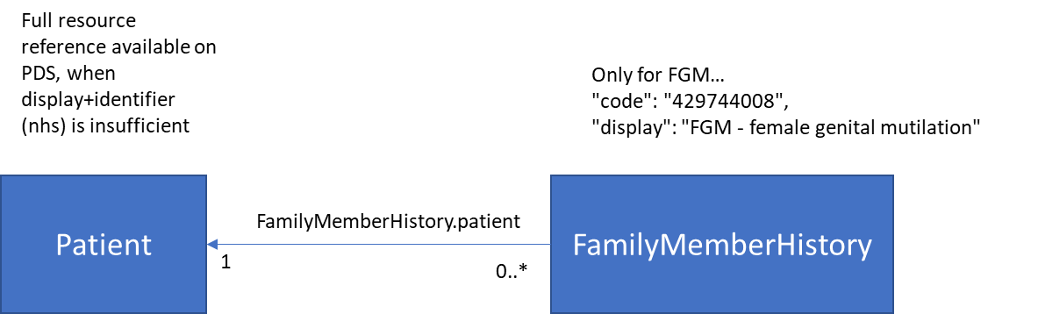

Mapping:

A high level mapping to the current FGM risk indicator:

|  |  |
| --- | --- |
| *Data item* | *FHIR Target* |
| FGM Risk Indicator | *Inferred by API returning 1 or more FGM FamilyMemberHistory results.* |
| Start date | FamilyMemberHistory.date |
| NHS identifier | FamilyMemberHistory.patient.identifier  Further patient details via PDS reference. E.g. GP practice |

Example:

{

"resourceType": "FamilyMemberHistory",

"id": "6884491e-ecff-4e23-9e4c-806e70230bd4",

"status": "completed",

"patient": {

"reference": "https://api.service.nhs.uk/personal-demographics/FHIR/R4/Patient/9000000009",

"display" : "Miss Davina Patient",

"identifier": {

"system": "https://fhir.nhs.uk/Id/nhs-number",

"value": "9000000009"

}

},

"date": "2019-12-10T13:00:00+00:00",

"relationship": {

"coding": [

{

"system": "http://terminology.hl7.org/CodeSystem/v3-RoleCode",

"code": "MTH",

"display": "mother"

}

]

},

"condition": [

{

"code": {

"coding": [

{

"system": "http://snomed.info/sct",

"code": "429744008",

"display": "FGM - female genital mutilation"

}

],

"text": "FGM - female genital mutilation"

}

}

]

}

Search interaction:

* **GET /***fgm_api*/FamilyMemberHistory?patient:identifier=https://fhir.nhs.uk/Id/nhs-number|9000000009

Headers

|  |  |
| --- | --- |
| *Data item* | *Header* |
| Source author | NHSD-Requesting-Practitioner |
| Source application | Authorization (should contain ASID) |
| Source organization (*optional*) | NHSD-End-User-Organisation-ODS |

Parameters

|  |  |
| --- | --- |
| *Name* | *Description* |
| patient:identifier | Required. Type: [token](https://hl7.org/implement/standards/FHIR/search.html%23token)  The patient's NHS number. The primary identifier of a patient across systems, unique to NHS England and Wales.  Example: https://fhir.nhs.uk/Id/nhs-number|9000000009 |

Create interaction:

* **Post /***fgm_api*/FamilyMemberHistory

Headers

|  |  |
| --- | --- |
| *Data item* | *Header* |
| Source author | NHSD-Requesting-Practitioner |
| Source application | Authorization (should contain ASID) |
| Source organization (*optional*) | NHSD-End-User-Organisation-ODS |

Parameters

|  |  |
| --- | --- |
| *Name* | *Description* |
| N/A for interaction | |

Request

|  |  |
| --- | --- |
| *Body* | Description |
| FamilyMemberHistory | Reference FGM FamilyMemberHistory example above.  Note: it assumed the patient’s GP organisation will be drawn from PDS rather than being included in the payload. The patient GP organisation is included in the existing API as [spine-gp-organization-1-0](https://fhir.nhs.uk/StructureDefinition/spine-gp-organization-1-0) profile. |

Errors:

|  |  |
| --- | --- |
| *Name* | *Description* |
| Condition.code | Allowed values: 429744008 |
| Mandatory elements check | Always need a:  - *verified* patient  - condition.code  - date |

Conditional Delete interaction by NHS number:

A conditional delete by NHS number. This removes all FGM FamilyHistoryMember resources held against the patient. Indicating that the caller believes the patient is no longer at risk of FGM.

* **Delete /***fgm_api*/FamilyMemberHistory?patient:identifier=https://fhir.nhs.uk/Id/nhs-number|9000000009

Headers

|  |  |
| --- | --- |
| *Data item* | *Header* |
| Source author | NHSD-Requesting-Practitioner |
| Source application | Authorization (should contain ASID) |
| Source organization (*optional*) | NHSD-End-User-Organisation-ODS |
| Removal reason | NHSD-Flag-Removal-Reason |

Parameters

|  |  |
| --- | --- |
| *Name* | *Description* |
| [id] | Required.  A verified patient NHS number |

Errors

|  |  |
| --- | --- |
| *Name* | *Description* |
|  | Reject if application / role not allowed to delete FGM risk records. |

Delete interaction by id:

A delete by id. This removes a particular FamilyMemberHistory resource held against the patient. If it is the only FamilyMemberHistory resource held against the patient then that indicates the patient is no longer at risk of FGM.

* **Delete /***fgm_api*/FamilyMemberHistory/95d18386-a85b-4085-9f3f-245c8de6fc51

Headers

|  |  |
| --- | --- |
| *Data item* | *Header* |
| Source author | NHSD-Requesting-Practitioner |
| Source application | Authorization (should contain ASID) |
| Source organization (*optional*) | NHSD-End-User-Organisation-ODS |
| Removal reason | NHSD-Flag-Removal-Reason |

Parameters

|  |  |
| --- | --- |
| Name | Description |
| [id] | Required.  A FamilyMemberHistory id |

Errors

|  |  |
| --- | --- |
| Name | Description |
|  | Reject if application / role not allowed to delete FGM FamilyMemberHistory resource. |

Update Interaction:

* **PUT /***fgm_api*/FamilyMemberHistory/95d18386-a85b-4085-9f3f-245c8de6fc51

Headers

|  |  |
| --- | --- |
| *Data item* | *Header* |
| Source author | NHSD-Requesting-Practitioner |
| Source application | Authorization (should contain ASID) |
| Source organization (*optional*) | NHSD-End-User-Organisation-ODS |

Parameters

|  |  |
| --- | --- |
| Name | Description |
| [id] | Required.  The UUID of the FamilyMemberHistory |

Request

|  |  |
| --- | --- |
| *Body* | Description |
| FamilyMemberHistory | Reference FGM FamilyMemberHistory example above.  Note: it assumed the patient’s GP organisation will be drawn from PDS rather than being included in the payload. The patient GP organisation is included in the existing API as [spine-gp-organization-1-0](https://fhir.nhs.uk/StructureDefinition/spine-gp-organization-1-0) profile. |

Errors

|  |  |
| --- | --- |
| Name | Description |
| Patient | Not allowed to change linked patient. |
| Condition.code | Allowed values: 429744008 |
| Mandatory elements check | Always need a *verified* patient, category and code, period start. |

#### 3.9.3.1 Option 3 Review

Pros

1. Currently the FGM indicator is termed a risk indicator i.e. which seems like a Flag as in option 1 and 2. Option 3 exists as it may be debatable if this is a risk or information sharing? If it is information sharing then FamilyMemberHistory is less intrusive. Whereas if it is a risk then Flag is correct as it is intended for alerts and prominent information. Some potential support for information sharing. <https://nhsd-confluence.digital.nhs.uk/display/SCREDISC/Existing+personas?preview=%2F351994081%2F376512928%2FPersona+-+Midwife+-+FGM-IS.pdf>

Cons

1. More complex as FamilyMemberHistory could be 1..* against Patient for FGM. E.g. does a delete remove all records held or just one?
2. Is a child only at risk of FGM via previous family history? If it is more subjective than that then modelling with FamilyMemberHistory would be too restrictive
3. Inferring that there is a risk by presence of 1 or more FamilyMemberHistory results in a search set seems questionable.
4. Probably wouldn’t fit with the same database schema on the Spine that the current FGM API uses. Primarily because the current FGM risk indicator is 1..1 with the patient. FamilyMemberHistory could be 1..*.

#### **3.9.3.2 Estimate timeline, cost and effort**

This option was rejectedby the IOPS design authority, for the following reasons:

1. There is no requirement to record the FGM risk indicator as a Bundle of FamilyMemberHistory resources.
2. If the definition of the risk indicator moves away from a family history of FGM to something more generic then Flag would be the most generic resource to use.
3. The intention is ultimately o provide an alert to the healthcare worker. Fkag is the appropriate resource for high level alerts.

Consequently, no estimation of time, cost or effort will be produced as this option is not recommended for implementation.

## 3.10. Issues/Decision Log

Issues and Decisions encountered during the Project and any decision DA have made on these issues.

|  |  |  |  |  |
| --- | --- | --- | --- | --- |
| Date Raised | Issue / Decision | Description | Action | Resolution Date |
| 14/06/23 | DELETE versus PUT | A generic pattern to remove a resource with a reason is needed. DELETE with an extension was recommended at IOPS DA. | Update this discovery document | 16/06/23 |
| 14/06/23 | Façade for a new FHIR version on top of a database initially designed for an earlier version. | Can transformation be performed in/out of API orchestration layer to meet specific version specification Yes, some transformation would be expected to meet the current best practices.  E.g. transforming a custom valueset value to an equivalent snomed code for new API – Flag.code. | Record advice here | 16/06/23 |
| 14/06/23 | How to reference national datastores. | Should a reference have identifier, reference and display value e.g. PDS. Definitively identifier. Display and reference optional. | Update this discovery document. | 16/06/23 |

# Design Authority Approval

The outcome of DA Design Approval Request.

|  |  |  |
| --- | --- | --- |
| Date | Decision | Notes |
| 16/06/23 | Option 1 preferred. Flag seems most relevant. |  |